**FiberFlex® and FiberFlex® Extreme**

**Installation Instructions**

## **Table of Contents**

# 1 Before you Start

# 2 Tools Needed

# 3 Subfloor Preparation

# Subfloor Preparation – FiberFlex® Extreme

# Cutting, Fitting and Laying

# 5 Seaming and Adhesives

# Flash Coving

# 7 Corners

# 8 Seam Sealing

# 1 Before you Start

# Before starting any project involving WorldProof Products, check with all local building, and health codes and obtain permits as needed. Adhere to all local, state, and federal safety regulations throughout the process of installing WorldProof flooring products. FiberFlex® flooring installation requires safe work habits in a safe environment. Installers should review and follow all safety and health information available such as Material Safety Data Sheets (MSDS), labels, instructions, specifications, and other pertinent publications.

# The installation of FiberFlex® should be performed by a professional flooring installer, familiar with the unique characteristics of FiberFlex®, local building codes, and ASTM Standards.

# Regardless of where FiberFlex® floor covering is installed, all seams (horizontal or vertical) and internal and external corners must be cut in, grooved and chemical welded to provide a floor surface conforming to the highest standards of safety and hygiene.

* + - Rolls used in any one area must be from the same manufacturing batch and laid in numerical sequential order.
    - For shade matching, do not lay rolls at right angles to each other.

# 2 Tools Needed

* FiberFlex®
* Adhesive
* Congoleum SU106 seam sealer
* Trowels (for self-leveler and adhesive)
* Seaming tape and liquid seam sealer (if needed)
* Small hand roller and 100 lb. roller
* Vacuum, broom, and dustpan
* Hammer and nail punch
* Utility knives and spare blades
* Self-leveler
* Transition strips
* Vinyl cove base, cap and cove
* Caulk gun and caulk
* Double-sided tape
* Rags and trash bags
* Safety gear:Safety glasses, chemical and/or cut resistant protective gloves, knee pads, eye wash, first aid kit, closed toe work shoes, hearing protection, and dust masks*
* Tool cleaning solvents
* Thresholds (and reducers for transitions from FiberFlex to other flooring)

*All safety gear must be in compliant with OSHA requirements

# 3 Subfloor Preparation

* + - WorldProof recommends installing FiberFlex® only over structurally sound, clean, dry concrete or concrete board (½” minimum), or underlayment grade plywood.
    - Subfloors must be prepared as documented in the Resilient Floor Covering Institute Installation Practice #1 [www.RFCI.com](http://www.RFCI.com/) and as recommended by WorldProof.
    - Complete all patching and leveling needed in wet areas such as commercial kitchens, showers, swimming pool surrounds, and all other wet areas, with a moisture tolerant patching and leveling material. per manufacturer’s instructions.
    - Remove all stains, varnish, paint, sealants, and adhesives from wood floors. If this is not possible, then cover with an appropriate underlayment. Luan products are NEVER recommended for use under FiberFlex® flooring.
    - We also do not recommend applying FiberFlex® on existing finished flooring such as, but not limited to tile, VCT, epoxy, resilient, and quartz.
    - All wood underlayment/sub-floors should be solid, well nailed at the joints, and free from movement.

**Note: WorldProof is not responsible for failures related to inadequate subfloor preparation. We do not warrantee our products if the subfloor is not prepared appropriately.**

* + - Conduct moisture tests per ASTM F2170 on all concrete slabs regardless of age or grade level.
    - The substrate must be smooth, clean, and dry. Always broom sweep and shop vacuum to ensure that all dust and debris have been removed.
    - ALL on-grade and below-grade concrete floors should have an existing vapor barrier (10 mil/0.010 in.) installed below the slab.
    - The concrete sub-floor should be dry, smooth, and structurally sound. It must be flat and level except for sloping to drains. It should be free of depression, scale, and foreign deposits of any kind.
    - Degrease and remove stains in surface and grind smooth or sealed surface to create a finish suitable for mechanical bond. Low spots, cracks, joints, and damaged areas should be leveled and faired to achieve a consistent level surface.
    - Fill rough, uneven, score marked, cracked concrete (if it is structurally-sound) be filled with a leveling compound must be of a cementitious type (non-gypsum); they must be moisture-, mildew-, and alkali-resistant, and must provide a minimum of 3500 psi.
    - Perform Adhesion tests when considering what filler/leveler to use. Cement type underlayment boards (minimum ½”) can be used. Do not apply FiberFlex® over expansion joints. Remove concrete curing/drying compounds prior to adhering FiberFlex®.
    - If high Moisture Vapor Emission Rates (MVER), relative humidity levels, or alkalinity levels exist, then a surface-applied vapor reduction system may be needed. Any moisture reduction system must be compatible with WorldProof certified adhesives. Adhesion tests are recommended. The moisture/vapor barrier’s performance and warranty are the responsibility of their manufacturer, end-user, and installer, not WorldProof.
    - Floor drains, of any type and size, should be properly sloped before applying FiberFlex®.
    - FiberFlex® should never be installed over gypsum-based sub-floors, underlayment, or fillers.
    - FiberFlex may be adhered over radiant-heated floors provided the maximum temperature of the floor does not exceed 105°F and maximum water temperature does not exceed 125°F.
    - FiberFlex® should not be permanently installed over existing finished flooring of any kind or type. WorldProof recommends either completely removing the existing flooring down to the sub-floor or applying an appropriate underlayment prior to installation.
    - Metal surfaces require the application of ¾” marine-grade plywood or ½” concrete board prior to the installation of FiberFlex.

# Subfloor Preparation – FiberFlex® Extreme

# Any irregularities and contaminants will telegraph through FiberFlex® Extreme.

# To avoid this problem, be extra careful that the substrate is contaminate-free, smooth, and level.

**Note: WorldProof is not responsible for failures related to inadequate subfloor preparation. We do not warrantee our products if the subfloor is not prepared appropriately.**

# 4 Cutting, Fitting and Laying

* + - Make rough cuts and let the FiberFlex® become conditioned to the recommended installation temperature. This allows the material to “relax” and makes it easier to install.
    - Check carefully to see that rolls match in shade. If shades do not match, **do not install**. **Contact your WorldProof distributor**.
    - When cutting to length, allow 1” at each end for trimming.
    - Check the flooring for defects. If a fault has been found, **do not proceed**. **Warranty claims against defective material only apply if the flooring has not yet been permanently bonded.**
    - Cut into lengths as determined by the flooring design.
    - Allow lengths to lay loose for 2 hours to assist in conditioning the flooring.
    - Back roll lengths to remove any remaining tension in the product.
    - Lay all rolls and cuts in consecutive order.

# Adhesives

* **NOTE: ONLY use adhesives certified for use by WorldProof. Because of the unique makeup of our products, many adhesives will not properly adhere. If you use a different adhesive, off-gassing may occur.**
* **DO NOT use 2-part adhesive for FiberFlex®; use it only for FiberFlex® Extreme.**
  + - Immediately roll the flooring from center out to edges, use a 100 lb (45kg) roller to ensure complete contact of flooring material to the adhesive and ensure air there is no air between the back of the FiberFlex® and the subfloor. Roll again to ensure there are no air pockets.
    - Expel all trapped air by using a 100 lb (45 kg) roller. Place weights such as sandbags over seams or around drains or in areas where you need to apply pressure. This will keep the back of the FiberFlex® on the adhesive until the adhesive has set.

# 6 Flash Coving

## If flash coves are specified, then walls must be sound, solid, smooth, dry and clean.

## Traditional fillet cove products should be used at floor/wall transition.

## To complete FeberFlex ® termination on wall, select cap vinyl or subber solution that meets the aesthetic finish requirements.

## After sub-floor preparation, install cove stick and cap strip as noted below:

* + 1. Apply contact tape to the areas being covered per tape manufacturers’ instructions.
    2. Install FiberFlex® tightly down and onto the cove stick and trim the flooring to the cap as required.
    3. Fit floor covering into cap strip and roll with a hand roller.
    4. Always seal top of cap with appropriate caulking.

1. Push FiberFlex® as far as possible into the internal corner.

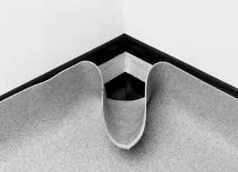

1. Make a cut from the base to the top of the FiberFlex® in line with the corner.



1. Fold in one side and gradually cut off the surplus FiberFlex® to complete the first part of the corner.

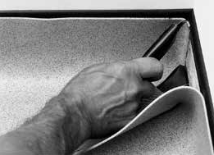

1. Fold in the second side. 5. Gradually trim the surplus material to achieve a net fit.

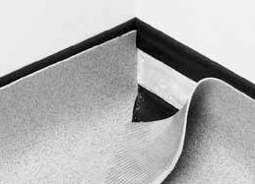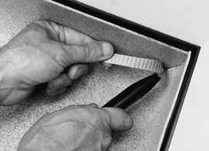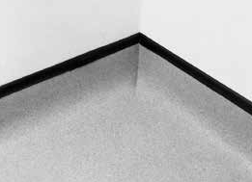

1. Chemical weld to complete the section.

## Corners

## Forming corners using butterfly pieces

Use butterfly pieces, also called V-plugs for installations where traffic impacts outside corners.

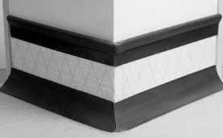

* 1. In​stall cap strip and cove stick using approved contact tape. Round the outside miter on the cove stick at the subfloor line then shape it to match the radius of the cove stick.
  2. To​ cut a butterfly piece:

Cut​ a rectangle from a scrap of FiberFlex®.

A = height of the cove x 2

B = distance from the top of the cap strip to half-way down the radius of the cove stick.

Cut a​long lines C and D to make a triangle. Round the bottom point to the radius of a penny.

* 1. Fo​lding a butterfly piece:

Fold the fill piece flat, back-to-back and along the center line.

Open to 90°.

* 1. Fi​nished butterfly piece. 5. Place contact tape on the back of the corner. Fit the fill piece up under the lip of the cap strip and press into place.

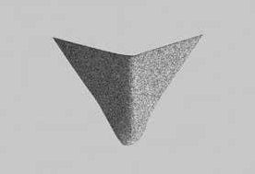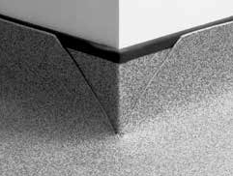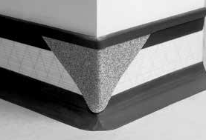

6.Once the butterfly corner is in place, spread adhesive and lay FiberFlex® into position. Make relief cuts so FiberFlex® overlaps both edges and the bottom point of the corner fill.

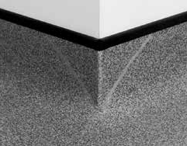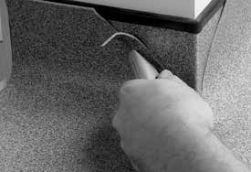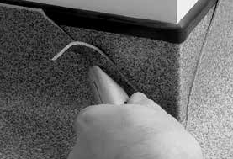

1. Ensure FiberFlex is held firmly down against the cove stick while making the final cut.
2. Using a hook blade or concave blade, trim FiberFlex® to fit net to the perimeter of the butterfly corner fill.
3. Groove and chemical weld to complete the section.

* When adhesive has set, chemical weld all corners.
* Use a butterfly piece for external corners fitted net without any gaps.
* Cut internal corners to fit without any gaps.

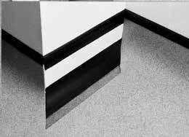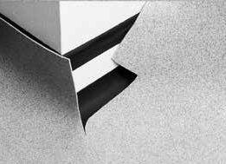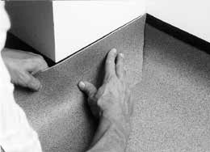

1. Roughly cut FiberFlex® oversize to meet the required section.

2. Cut in the back and front corner, then cut out the section to accommodate the filler piece.

3. Take a separate piece of FiberFlex® and fit to the back of the internal corner.

4. Cut in the front of the external corner.

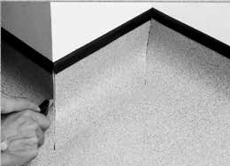

5. Chemical weld to complete the section.

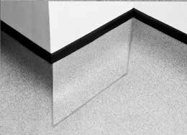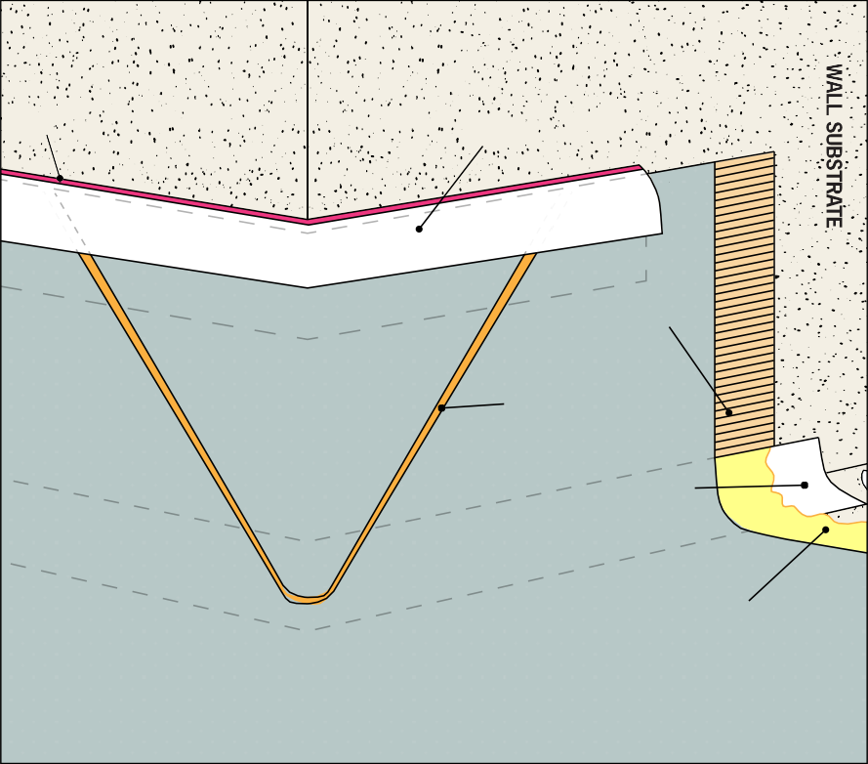

WorldProof sanitary

sealant

WorldProof C7

capping strip

Contact tape

Chemical welded seam

Cove former

Appropriate

WorldProof adhesive

**FiberFlex®**

# 

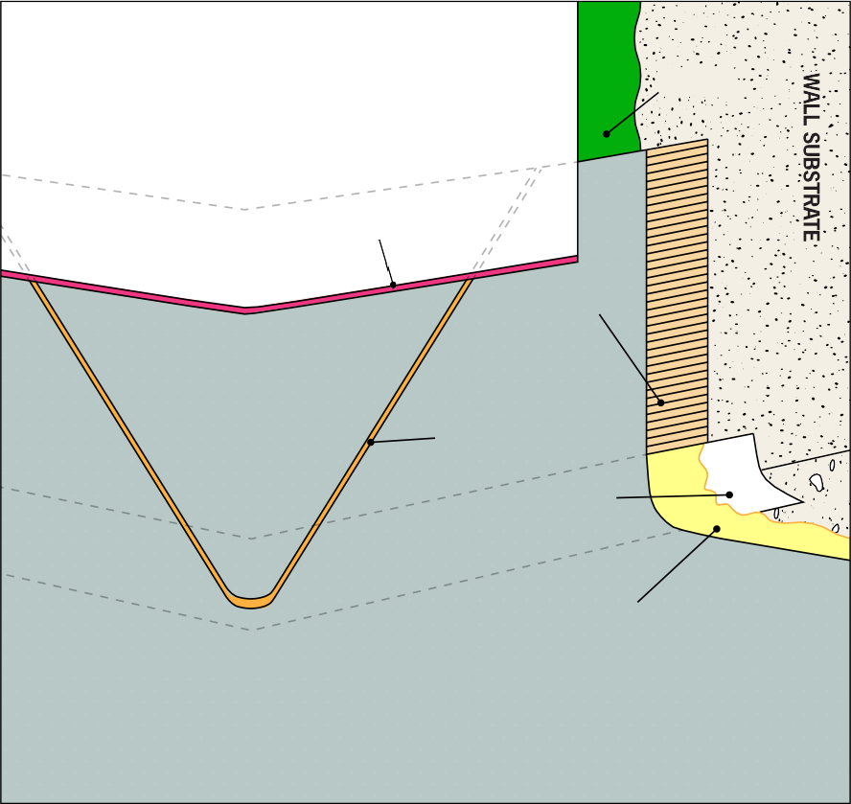

Appropriate

WorldProof adhesive

WorldProof sanitary

sealant

Contact tape

Chemical welded seam

Cove former

Appropriate

WorldProof adhesive

**FiberFlex®**

Butterfly corner with cap strip

Butterfly corner overlap transition

# 

# 8 Seam Sealing

* + - ONLY use the seaming material recommended by WorldProof: Congoleum SU 106. Because of the unique composition of our products, other materials do not work effectively. If this product is not readily available in your market, we will ship it to you.
    - **Follow the instructions (contained within the box), exactly as specified. If instructions are not followed exactly, WorldProof will not warrantee the seams.**
    - Do not butt factory edges.
    - Place material into position and overlap the seam edges 1” (25mm).
    - Trace cut FiberFlex® seams using a scoring blade followed by a hook blade. Use the trimmed edge as a guide.
    - Straight edge and butt short seams, such as those needed by doorways.